KWolley
10/7/20118
Problem Set 6
- Old school application of binary numbers
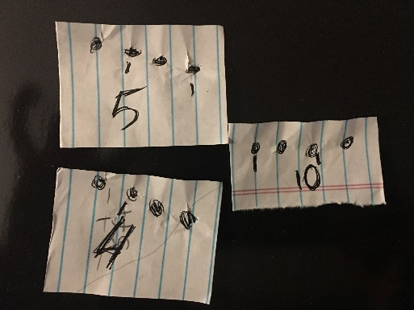
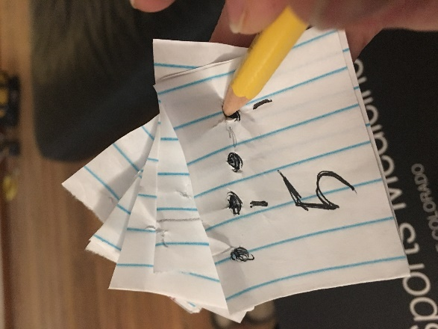 | 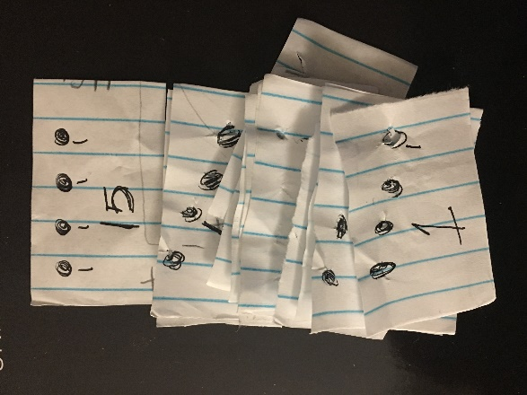

- Amazing Card Trick
The amazing card trick works because there are 4 suits and 13 numbers in a 52-card deck. 4 and 13 are both divisors of 52. If the deck is pre-ordered so that the cards alternate red and black suits and in order of suits, then in every case, there is no combination of 4 cards that would contain more or less than two of color and one of every suit. Prediction of the 13th card would not be as successful (i.e. you are relying on more luck than probability) because no previous cards of the family of 4 suits are known therefore you would be able to predict the value of the card but not the suit. For this trick to work, you may leave any single card in any set of 4 face down as long as a total of 13 cards are placed on the table.
- RSA
  - What form were keys originally in? Is this some sort of numerical password?
  - What happens if the key is lost?
  - What is the capacity of the number of locks Alice can send out? Is there a point in which the number of locks get “lost” or reach capacity or if Alice can no longer receive the locks she has already sent out?
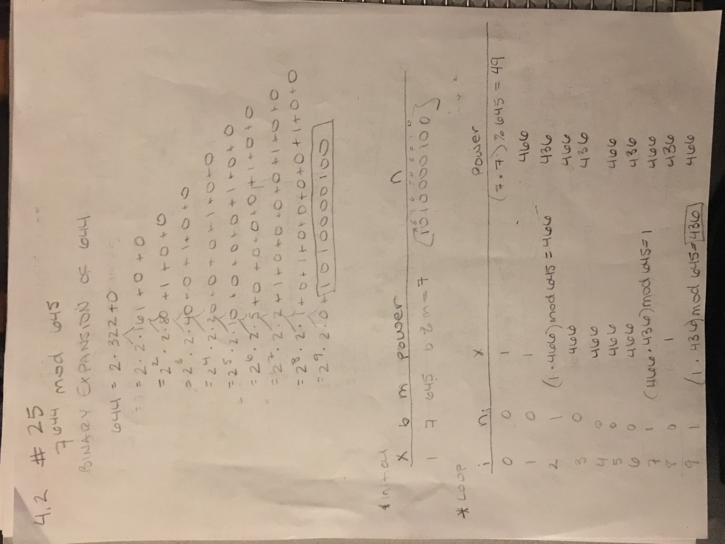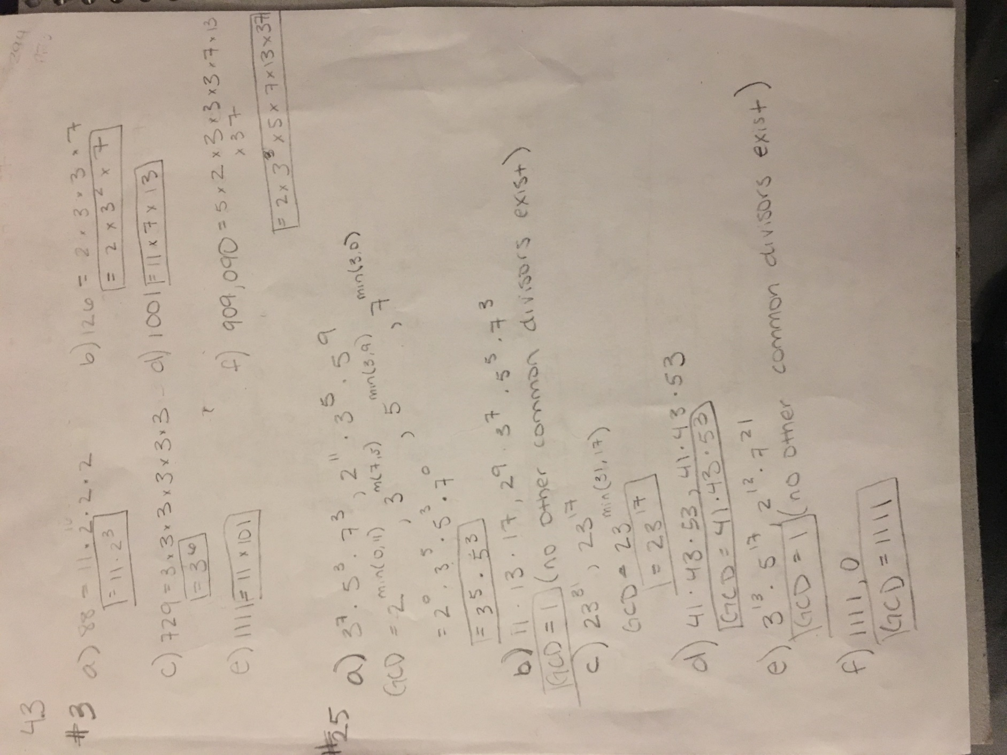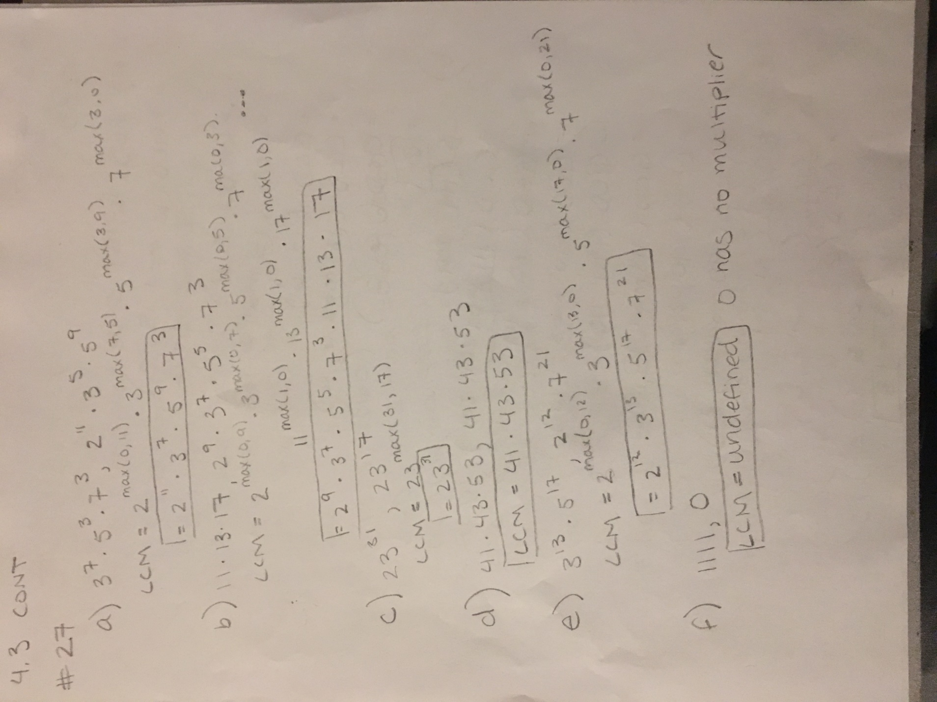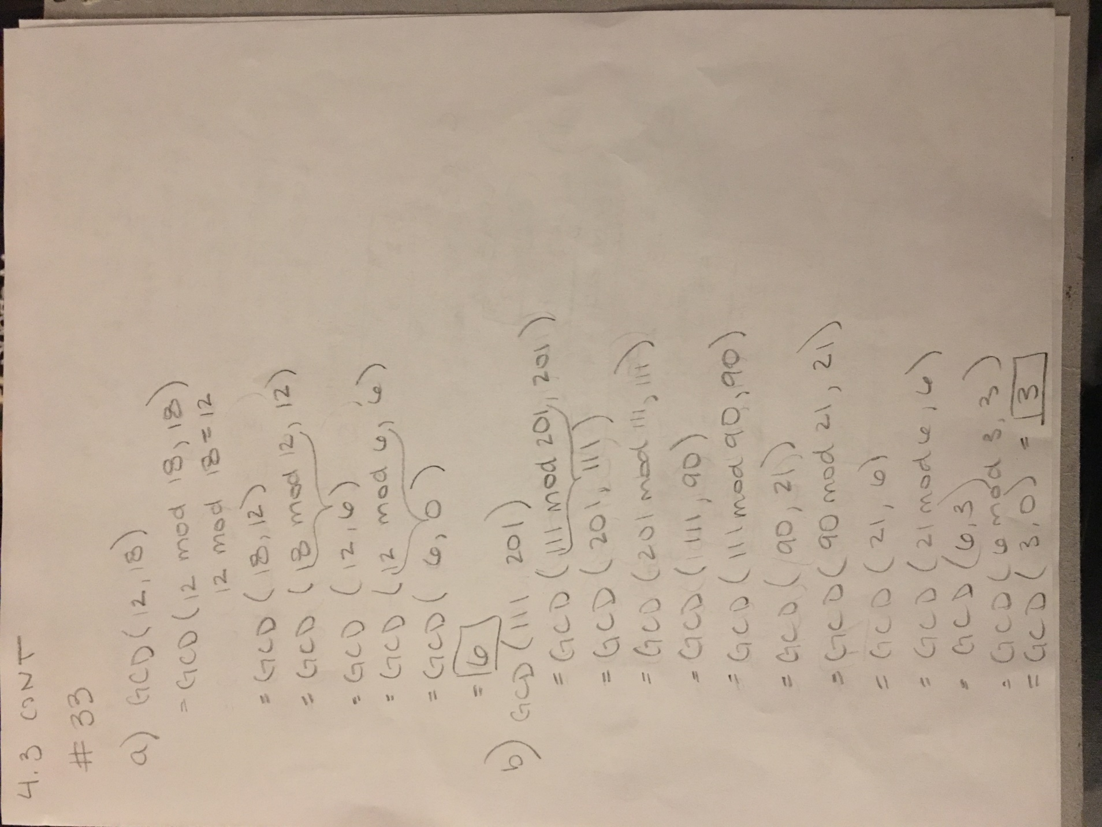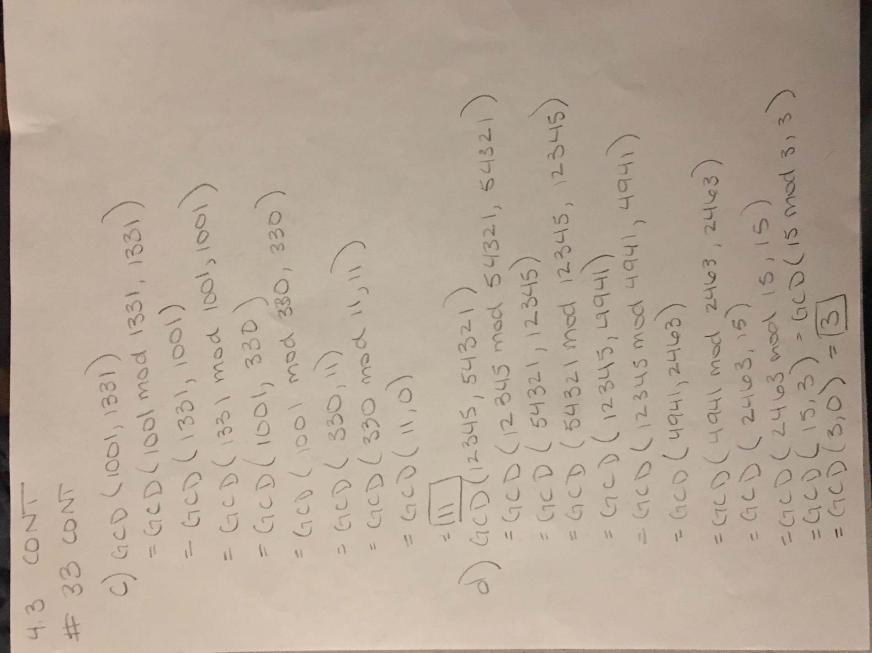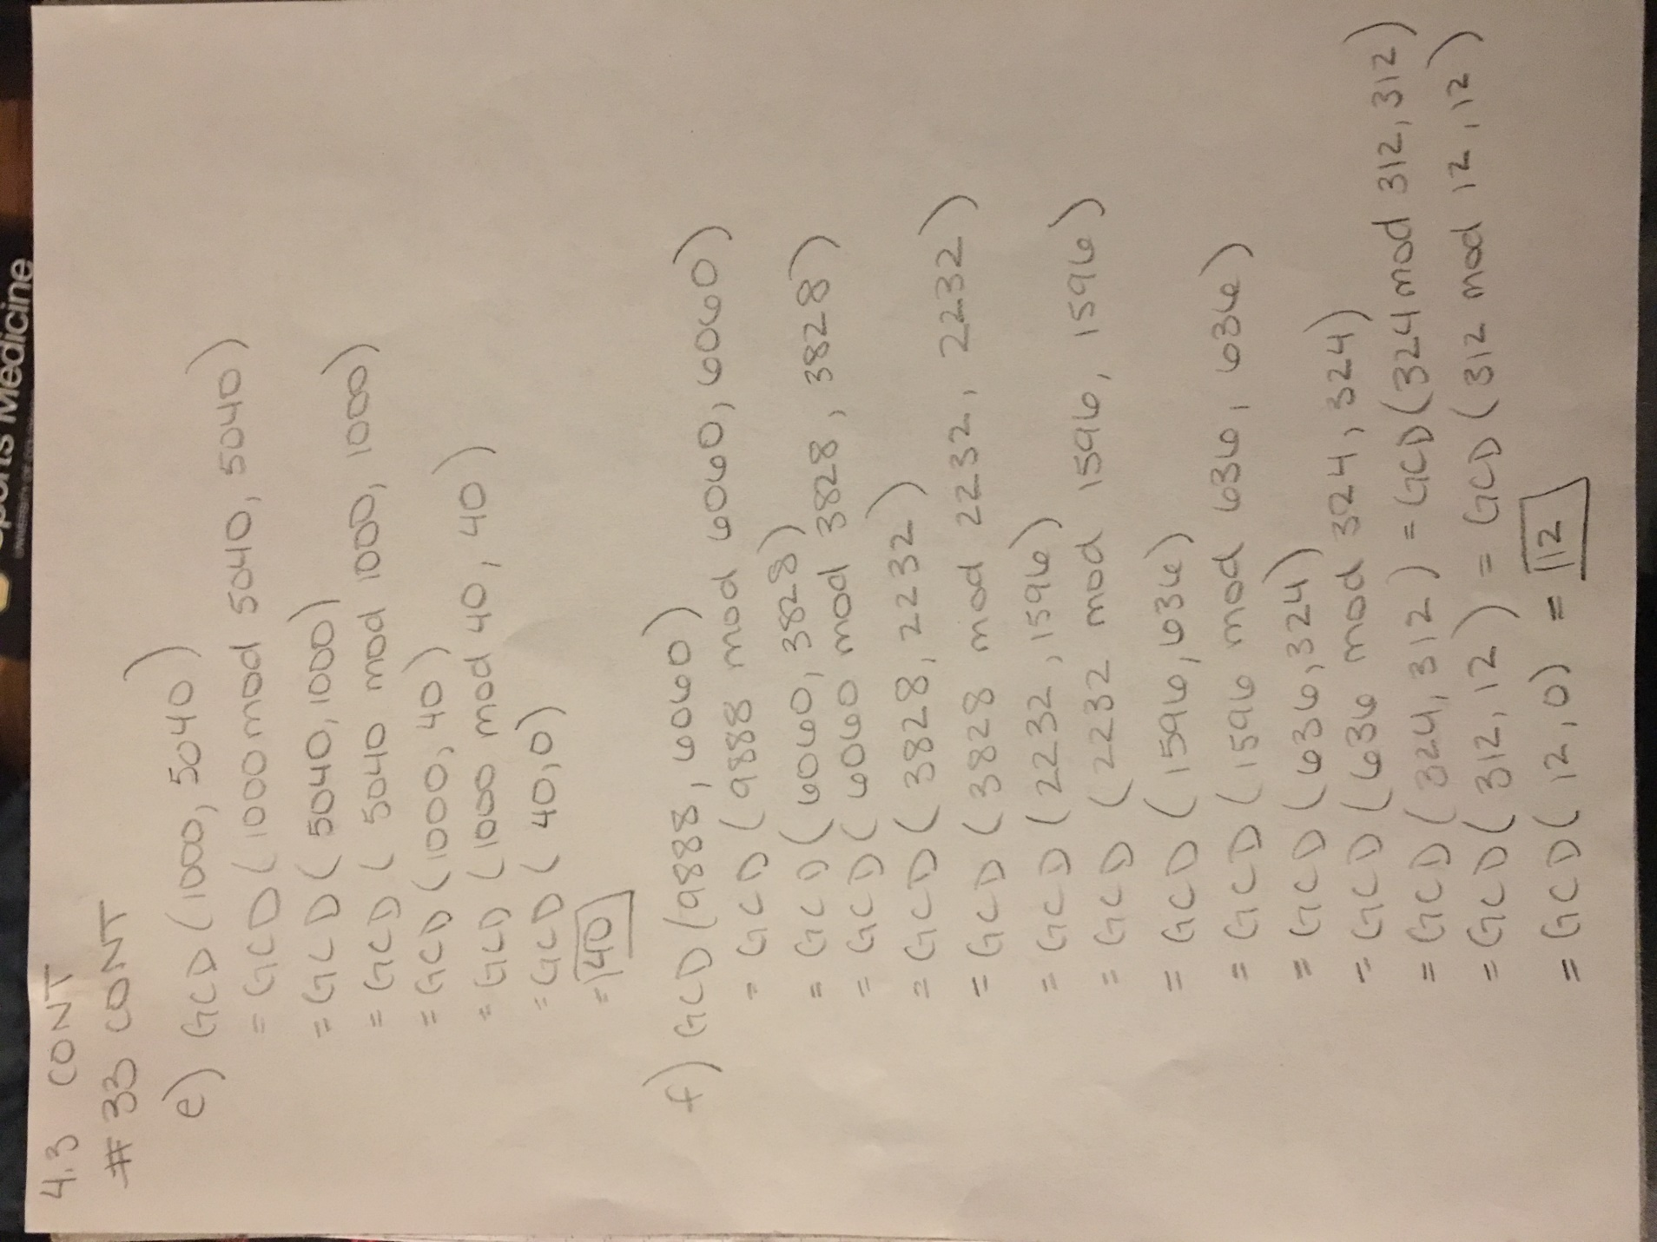

- Sieve of Eratosthenes – theorem 2
  - Prove that 100 must have a prime divisor <= 10
Let n = 100
Because n is a composite number it must also be true that n = a*b for integers a and b such that 1 < a < n and 1 < b < n.
Let $\sqrt{a}* \sqrt{b}= \sqrt{n}$ because a and b are divisors of n
$\sqrt{a}* \sqrt{b}= \sqrt{100}$
$\sqrt{a}* \sqrt{b}= 10$
Therefore, either a or b must be < 10 and either a or b (the divisors) are prime.
  - This could be used in cryptography as when two primes are multiplied it would be very difficult to factor these numbers into their primes. One would have to test all primes less than the number and see if a multiplication resulted in the desired number.

